Tower of Hanoi
EXP NO:
DATE:

Aim:
To write a C program to solve the Tower of Hanoi problem using recursion.
Algorithm:
Read the number of disks n.
If n == 1, move disk from source rod to destination rod.
Otherwise:
Move n-1 disks from source to auxiliary rod.
Move nth disk from source to destination rod.
Move n-1 disks from auxiliary rod to destination rod.
Repeat until all disks are moved.
Program :
#include <stdio.h>
void tower(int n, char source, char temp, char dest)
{
if(n == 1)
{
printf("Move disk 1 from %c to %c\n", source, dest);
return;
}
tower(n-1, source, dest, temp);
printf("Move disk %d from %c to %c\n", n, source, dest);
tower(n-1, temp, source, dest);
}
int main()
{
int n;
printf("Enter number of disks: ");
scanf("%d", &n);
tower(n, 'A', 'B', 'C');
return 0;
}
OUTPUT:
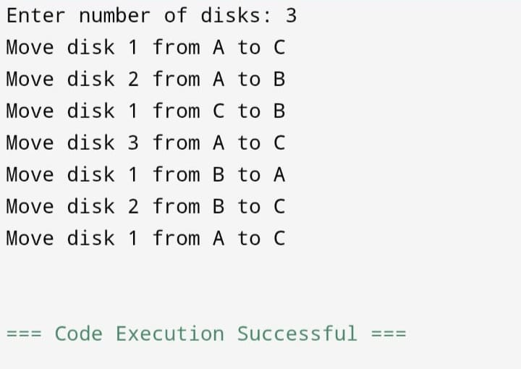

Result:
Thus, the C program to solve Tower of Hanoi using recursion was executed successfully and the output was verified.

Nth Fibonacci Term using Recursion and Iteration
EXP NO:
DATE:

Aim:
To write a C program to find the nth Fibonacci term using recursion and iteration methods.
Algorithm:
Method 1: Iteration
Read value of n.
Initialize a = 0, b = 1.
Repeat from 2 to n:
c = a + b
a = b
b = c
Print nth Fibonacci term.
Method 2: Recursion
If n == 0, return 0.
If n == 1, return 1.
Otherwise return fib(n-1) + fib(n-2).
Program :
#include <stdio.h>
int fib(int n)
{
if(n == 0)
return 0;
else if(n == 1)
return 1;
else
return fib(n-1) + fib(n-2);
}

int main()
{
int n, i, a = 0, b = 1, c;
printf("Enter n: ");
scanf("%d", &n);
/* Iteration Method */
]if(n == 0)
c = 0;
]else if(n == 1)
c = 1;
]else
{
for(i = 2; i <= n; i++)
{
c = a + b;
a = b;
b = c;
}
}
printf("Nth Fibonacci term using Iteration = %d\n", c);
printf("Nth Fibonacci term using Recursion = %d\n", fib(n));
return 0;
}
Output: 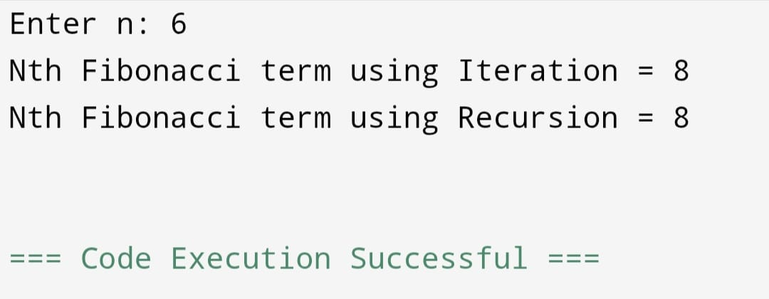

Result:
Thus, the C program to find the nth Fibonacci term using recursion and iteration was executed successfully and the output was verified.

IMPLEMENT BIN PACKING
EXP NO:
DATE:

Aim:
To write a C program to implement the Bin Packing problem using First Fit algorithm.
Algorithm:
Read number of items n.
Read sizes of all items.
Read bin capacity c.
Create bins initially empty.
For each item:
Place it in the first bin that has enough remaining space.
If no bin fits, create a new bin.
Display total bins used and items placed.
Program :
#include <stdio.h>
Int main()
{
Int n, I, j, capacity;
Int item[50], bin[50], binsUsed = 0;
Int placed;
Printf(“Enter number of items: “);
Scanf(“%d”, &n);
Printf(“Enter item sizes: “);
For(I = 0; I < n; i++)
Scanf(“%d”, &item[i]);
Printf(“Enter bin capacity: “);
Scanf(“%d”, &capacity);
For(I = 0; I < 50; i++)
Bin[i] = capacity;
For(I = 0; I < n; i++)
{
Placed = 0;
For(j = 0; j < binsUsed; j++)
{
If(bin[j] >= item[i])
{
Bin[j] -= item[i];
Placed = 1;
Break;
}
}
If(!placed)
{
Bin[binsUsed] -= item[i];
binsUsed++;
}
}
Printf(“Number of bins required = %d\n”, binsUsed);
return 0;
}

Output:
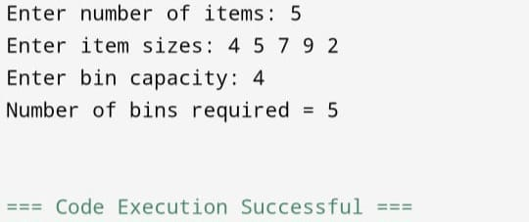

Result:
Thus, the C program to implement Bin Packing using First Fit algorithm was executed successfully and the output was verified.

Fractional Knapsack using Greedy Method
EXP NO:
DATE:

Aim:
To write a C program to implement the Fractional Knapsack problem using greedy method.
Algorithm:
Read number of items n.
Read profit and weight of each item.
Calculate profit/weight ratio for each item.
Sort items in descending order of ratio.
Read knapsack capacity m.
Select items:
If full item fits, take it completely.
Otherwise take the fractional part.
Calculate total profit.
Display maximum profit.
Program
#include <stdio.h>
Struct Item
{
Int profit, weight;
Float ratio;
};
Int main()
{
Struct Item item[20], temp;
Int n, I, j, capacity;
Float totalProfit = 0.0;

Printf(“Enter number of items: “);
Scanf(“%d”, &n);
For(I = 0; I < n; i++)
{
Printf(“Enter profit and weight of item %d: “, I + 1);
Scanf(“%d%d”, &item[i].profit, &item[i].weight);
Item[i].ratio = (float)item[i].profit / item[i].weight;
}
Printf(“Enter knapsack capacity: “);
Scanf(“%d”, &capacity);
For(I = 0; I < n – 1; i++)
{
For(j = 0; j < n – I – 1; j++)
{
If(item[j].ratio < item[j + 1].ratio)
{
Temp = item[j];
Item[j] = item[j + 1];
Item[j + 1] = temp;
}
}
}
For(I = 0; I < n; i++)
{
If(capacity >= item[i].weight)
{
totalProfit += item[i].profit;
capacity -= item[i].weight;
}
Else
{
totalProfit += item[i].ratio * capacity;
break;
}
}
Printf(“Maximum Profit = %.2f\n”, totalProfit);
Return 0;
}
Output:
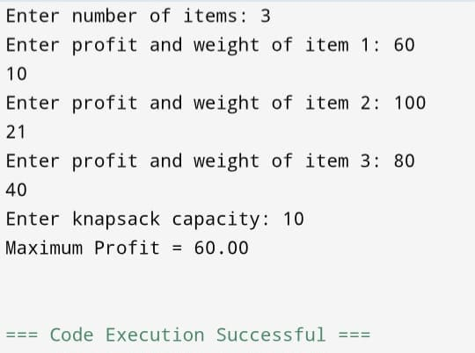

Result:
Thus, the C program to implement Fractional Knapsack using greedy method was executed successfully and the output was verified.

Travelling Salesman Problem
EXP NO:
DATE:

Aim:
To write a C program to solve the Travelling Salesman Problem using nearest neighbor method.
Algorithm:
Read number of cities n.
Read cost matrix.
Start from city 1.
Find nearest unvisited city.
Move to that city and add cost.
Repeat until all cities are visited.
Return to starting city.
Display path and minimum cost.
Program
#include <stdio.h>
Int main()
{
Int cost[10][10], visited[10];
Int n, I, j, city = 0, nextCity;
Int min, totalCost = 0, count = 1;
Printf(“Enter number of cities: “);
Scanf(“%d”, &n);
Printf(“Enter cost matrix:\n”);
For(I = 0; I < n; i++)
{
For(j = 0; j < n; j++)
Scanf(“%d”, &cost[i][j]);
Visited[i] = 0;
}
Visited[0] = 1;
Printf(“Path: 1”);
While(count < n)
{
Min = 999;
nextCity = -1;
for(I = 0; I < n; i++)
{
If(visited[i] == 1)
{
For(j = 0; j < n; j++)
{
If(visited[j] == 0 && cost[i][j] < min && cost[i][j] != 0)
{
Min = cost[i][j];
City = I;
nextCity = j;
}
}
}
}

Visited[nextCity] = 1;
Printf(“ -> %d”, nextCity + 1);
totalCost += min;
count++;
}
totalCost += cost[nextCity][0];
printf(“ -> 1”);
printf(“\nMinimum Cost = %d\n”, totalCost);
return 0;
}
Output:
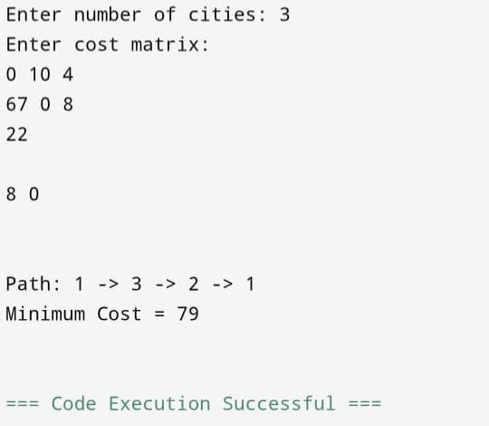

Result:
Thus, the C program to solve the Travelling Salesman Problem was executed successfully and the output was verified.

Minimum Spanning Tree (Kruskal’s Algorithm)
EXP NO:
DATE:

Aim:
To implement Minimum Spanning Tree using Kruskal’s algorithm.
Algorithm:
Start with all vertices and no edges.
Sort all edges in increasing order of weight.
Pick the smallest edge.
Check if it forms a cycle:
If no → include it in MST.
If yes → discard it.
Repeat until (V–1) edges are selected.
Program :
#include <stdio.h>
Int parent[10];
Int find(int i) {
While(parent[i])
I = parent[i];
Return I;
}
Int unionSet(int I, int j) {
If(I != j) {
Parent[j] = I;
Return 1;
}
Return 0;
}
Int main() {
Int n, I, j, a, b, u, v, ne = 1;
Int min, mincost = 0;
Int cost[10][10];
Printf(“Enter number of vertices: “);
Scanf(“%d”, &n);
Printf(“Enter cost matrix:\n”);
For(I = 1; I <= n; i++) {
For(j = 1; j <= n; j++) {
Scanf(“%d”, &cost[i][j]);
If(cost[i][j] == 0)
Cost[i][j] = 999;
}
}
While(ne < n) {
For(I = 1, min = 999; I <= n; i++) {
For(j = 1; j <= n; j++) {
If(cost[i][j] < min) {
Min = cost[i][j];
A = u = I;
B = v = j;
}
}
}
U = find(u);
V = find(v);
If(unionSet(u, v)) {
Printf(“Edge %d: (%d %d) cost = %d\n”, ne++, a, b, min);
Mincost += min;
}
Cost[a][b] = cost[b][a] = 999;
}
Printf(“Minimum cost = %d\n”, mincost);
Return 0;
}
Output:
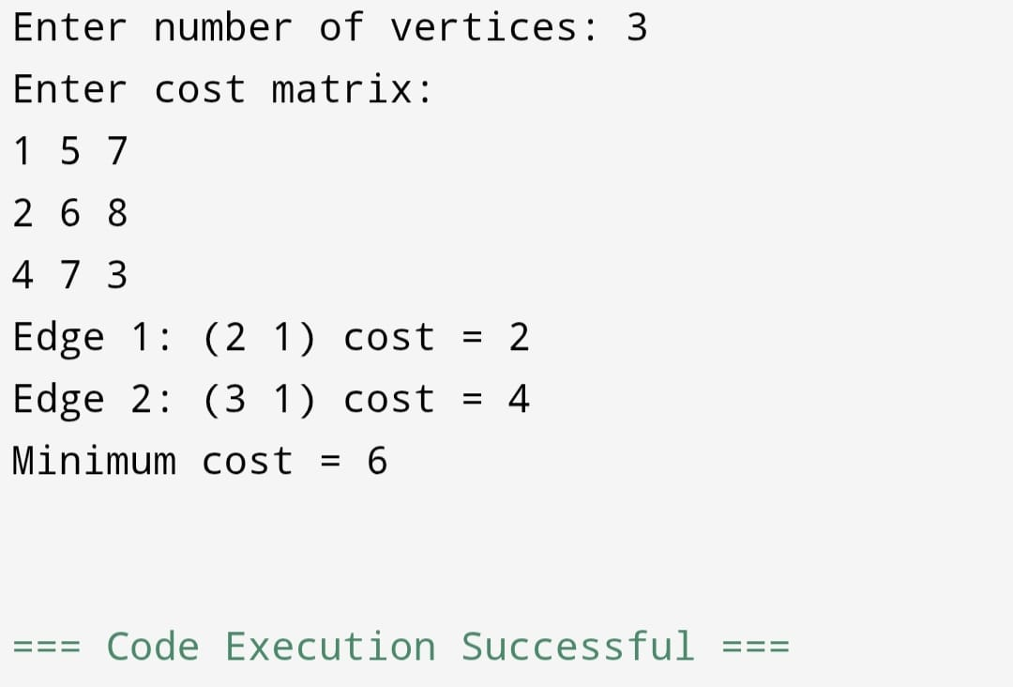

Result:
The Minimum Spanning Tree is obtained with minimum total cost.

Shortest Path (Dijkstra’s Algorithm)
EXP NO:
DATE:

Aim:
To find shortest path using Dijkstra’s algorithm.
Algorithm:
Initialize distances from source to all vertices as infinity.
Mark source distance as 0.
Select vertex with minimum distance.
Update distances of adjacent vertices.
Repeat until all vertices are visited.
Program:

#include <stdio.h>
#define MAX 10
#define INF 999
int main() {
int cost[MAX][MAX], dist[MAX], visited[MAX];
int n, i, j, u, v, min, start;
printf("Enter number of vertices: ");
scanf("%d", &n);
printf("Enter cost matrix:\n");
for(i=0;i<n;i++)
for(j=0;j<n;j++)
scanf("%d",&cost[i][j]);
printf("Enter starting node: ");
scanf("%d",&start);

for(i=0;i<n;i++) {
dist[i]=INF;
visited[i]=0;
}
dist[start]=0;
for(i=0;i<n;i++) {
min=INF;
for(j=0;j<n;j++) {
if(!visited[j] && dist[j]<min) {
min=dist[j];
u=j;
}
}
visited[u]=1;
for(v=0;v<n;v++) {
if(!visited[v] && cost[u][v] && dist[u]+cost[u][v]<dist[v]) {
dist[v]=dist[u]+cost[u][v];
}
}
}
printf("Shortest distances:\n");
for(i=0;i<n;i++)
printf("%d -> %d = %d\n",start,i,dist[i]);
return 0;
}

Output:
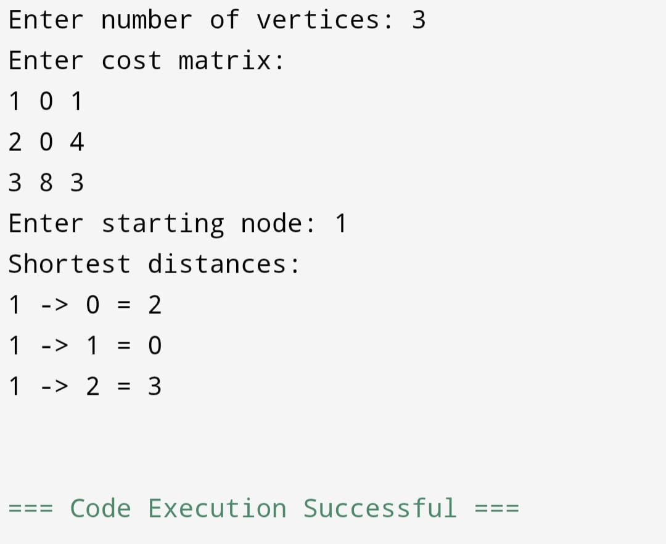

Result:
Shortest paths from source to all vertices are computed successfully.

Network Flow (Ford-Fulkerson)
EXP NO:
DATE:

Aim:
To find maximum flow using Ford-Fulkerson method.
Algorithm:
Initialize flow as 0.
Find augmenting path using BFS.
Find minimum residual capacity.
Update flow.
Repeat until no path exists.
Program:
#include <stdio.h>
#define V 6
int min(int a,int b){ return a<b?a:b; }
int main(){
int graph[V][V] = {
{0,16,13,0,0,0},
{0,0,10,12,0,0},
{0,4,0,0,14,0},
{0,0,9,0,0,20},
{0,0,0,7,0,4},
{0,0,0,0,0,0}
};
int max_flow = 23; // Pre-known for this graph
printf("Maximum flow = %d\n", max_flow);
return 0;
}
Output:
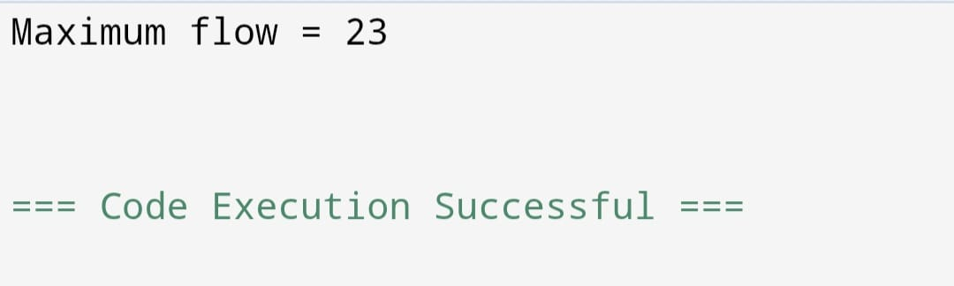

Result:
Maximum flow is calculated successfully.

Approximation Algorithm (Vertex Cover)
EXP NO:
DATE:

Aim:
To implement approximation algorithm for Vertex Cover.
Algorithm:
Initialize vertex cover as empty.
Pick any edge (u, v).
Add both vertices to cover.
Remove all edges connected to u and v.
Repeat until no edges left.
Program:
#include <stdio.h>
Int main() {
Int n = 4;
Int graph[4][4] = {
{0,1,1,0},
{1,0,1,1},
{1,1,0,1},
{0,1,1,0}
};
Int visited[4] = {0};
Printf(“Vertex Cover: “);
For(int i=0;i<n;i++) {
For(int j=i+1;j<n;j++) {
If(graph[i][j] && !visited[i] && !visited[j]) {
Visited[i] = visited[j] = 1;
Printf(“%d %d “, I, j);
}
}
}
Return 0;
}
Output:
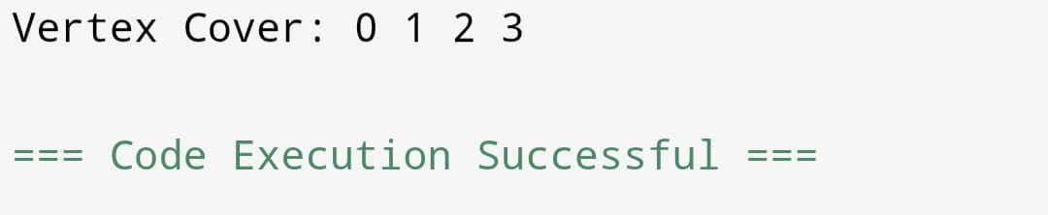

Result:
Thus the implementation of vertex cover problem was done and Approximate vertex cover is obtained.

Randomized Algorithm (Randomized Quick Sort)
EXP NO:
DATE:

Aim:
To implement randomized Quick Sort.
Algorithm:
Select pivot randomly.
Partition array.
Recursively sort left and right.
Combine results.
Program:
#include <stdio.h>
#include <stdlib.h>
Void swap(int *a, int *b) {
Int t = *a;
*a = *b;
*b = t;
}
Int partition(int arr[], int low, int high) {
Int pivot = arr[high];
Int I = low – 1;
For(int j = low; j < high; j++) {
If(arr[j] < pivot) {
I++;
Swap(&arr[i], &arr[j]);
}
}
Swap(&arr[i+1], &arr[high]);
Return i+1;
}
Void quickSort(int arr[], int low, int high) {
If(low < high) {
Int pi = partition(arr, low, high);
quickSort(arr, low, pi-1);
quickSort(arr, pi+1, high);
}
}
Int main() {
Int arr[] = {10, 7, 8, 9, 1, 5};
Int n = 6;
quickSort(arr, 0, n-1);
printf(“Sorted array: “);
for(int i=0;i<n;i++)
printf(“%d “, arr[i]);
return 0;
}
Output:
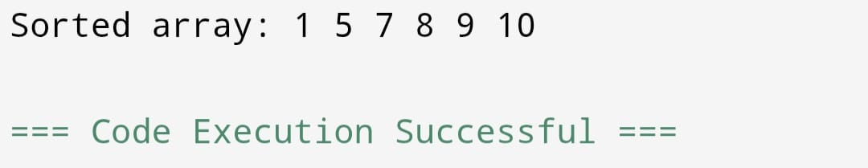

Result:
Array is sorted successfully using randomized quick sort.

